Purpose
To establish a procedure on how to gross and dictate adrenal glands for neoplasms. A normal adrenal gland measures 5 x 3 x 1 cm and weighs approximately 4 to 6 grams. The adrenal gland is composed of 2 main components: cortex and medulla. On sectioning, the cortex has a distinctive bright orange-yellow color. The medulla is a narrow, inner core, which has a pearly gray color. Most adrenal glands come with attached peri-adrenal adipose. Situated between the peri-adrenal adipose and cortex is the adrenal capsule.
Procedure
- Measure and weigh specimen after trimming off surrounding fat.
- Note any external abnormalities or defects and photograph.
- Ink entire external surface. Try to use different color ink to mark specific defects.
- Serially section the specimen along the long axis at 2-4 mm intervals.
- Photograph cut surfaces showing gross abnormalities.
- Measure mass(s) in 3 dimensions and describe location (cortex or medulla).
- Describe relationship of mass to capsule (abutting, invading through, etc.). If pertinent, relationship to peri-adrenal adipose or vasculature.
- Describe cut surfaces of mass including hemorrhage or necrosis.
- Describe uninvolved adrenal parenchyma, peri-adrenal adipose or any other findings.
- Note: Always submit a portion of adrenal tumor, along with normal gland, if present to tissue procurement.
Sections for Histology
- For aldosterone-secreting tumors that are relatively small and resected for treatment of the hyperaldosteronism, submit the entire gland and tumor(s). We need to find the source of the aldosterone via CYP11B2 IHC.
- For tumors that resected for concern for carcinoma, submit representative sections of tumor to normal gland and tumor to capsule (approximately 2 cassette per cm of greatest tumor dimension). Minimum number of tumor cassettes should be 10.
- Pheochromocytoma: Approximately 5-6 sections, including one of interface of neoplasm with normal gland.
- If adrenal medullary hyperplasia is suspected, e.g., MEN 2a, 2b or Von Hippel Lindau, submit medulla in toto.
- All other neoplasms submit approximately one section per cm of tumor to include uninvolved parenchyma.
Sample Dictation
“Left Adrenal Gland”, received in a small container filled with formalin is a 24.0 gm, 5.0 x 4.0 x 3.0 cm adrenalectomy specimen with attached peri-adipose tissue. Photographs are taken for future reference.
The gland is remarkable for a 2.0 x 1.0 x 0.5 cm well circumscribed, cortical mass. The mass abuts the capsule, however does not invade through it. The mass contains orange-yellow, solid and homogenous cut surfaces.
The remaining adrenal parenchyma and peri-adrenal adipose are unremarkable.
Inking Code: adrenal capsule=blue
Cassette Summary:
A1-A2. Cortical mass (1ss).
A3. Cortical mass to uninvolved adrenal parenchyma (1ss).
Sample Photographs
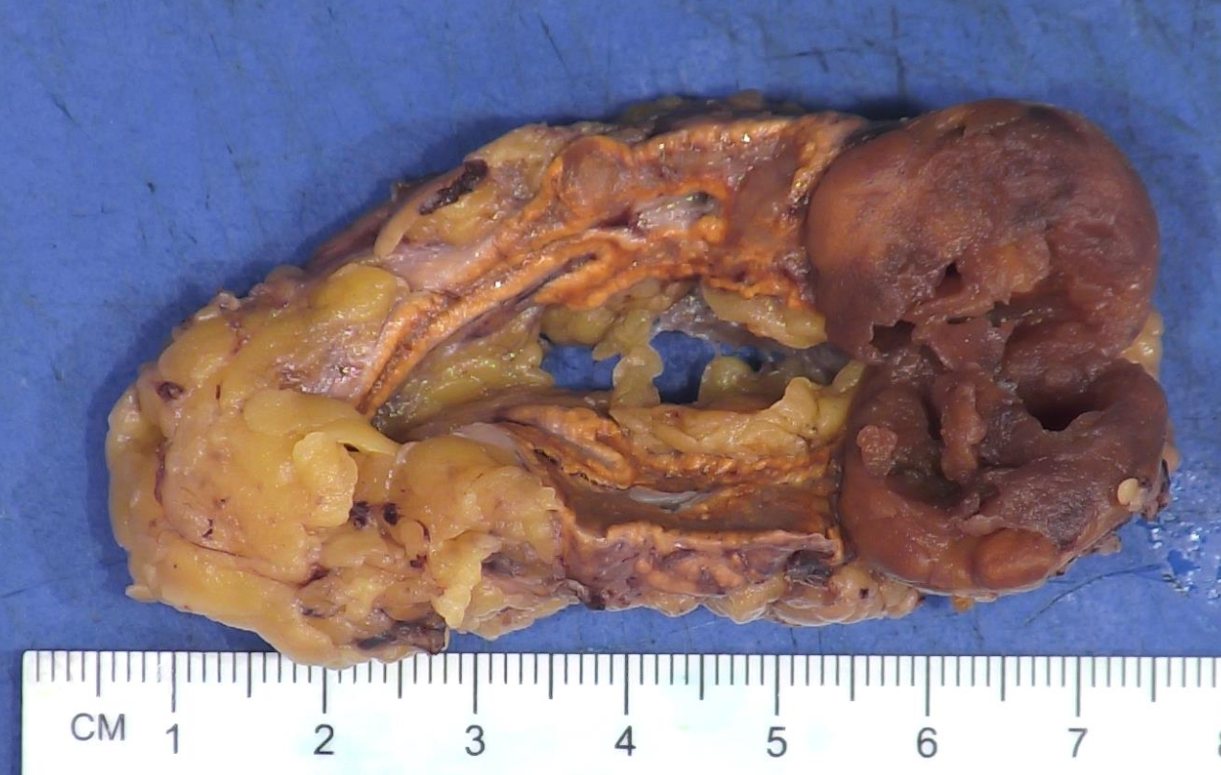
Figure 1. Pheochromocytoma (arising in medullary component).
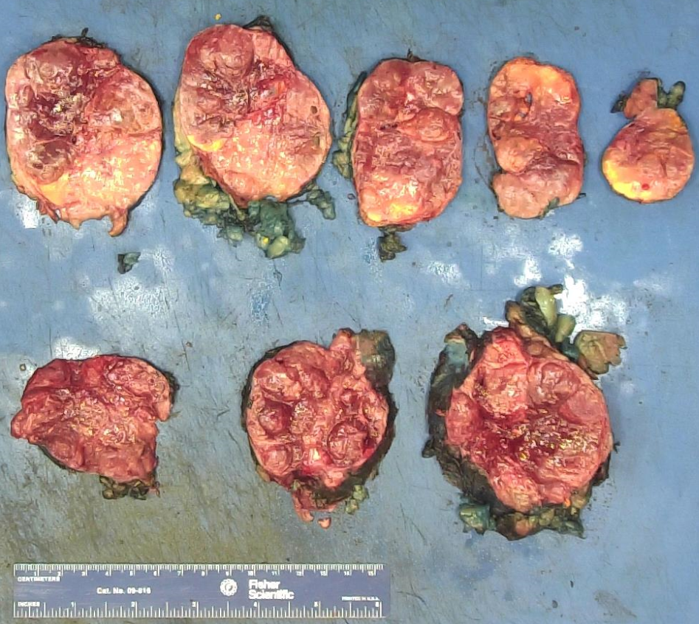
Figure 2. Adrenal Cortical Carcinoma
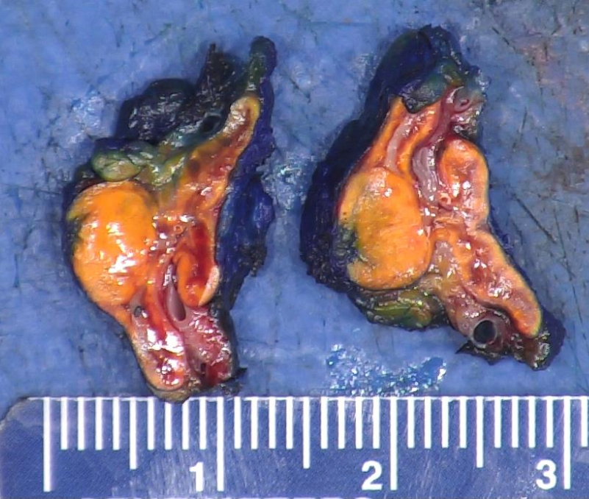
Figure 3. Aldosterone producing cortical nodule

